Project Design Phase-II
Data Flow Diagram & User Stories

Date | 08/03/2026
Team ID | SWTID-2026-2404
Project Name | LibSpace - A Robust Backend for Library Operations
Maximum Marks | 4 Marks

Data Flow Diagrams:
A Data Flow Diagram (DFD) is a traditional visual representation of the information flows within a system. A neat and clear DFD can depict the right amount of the system requirement graphically. It shows how data enters and leaves the system, what changes the information, and where data is stored.
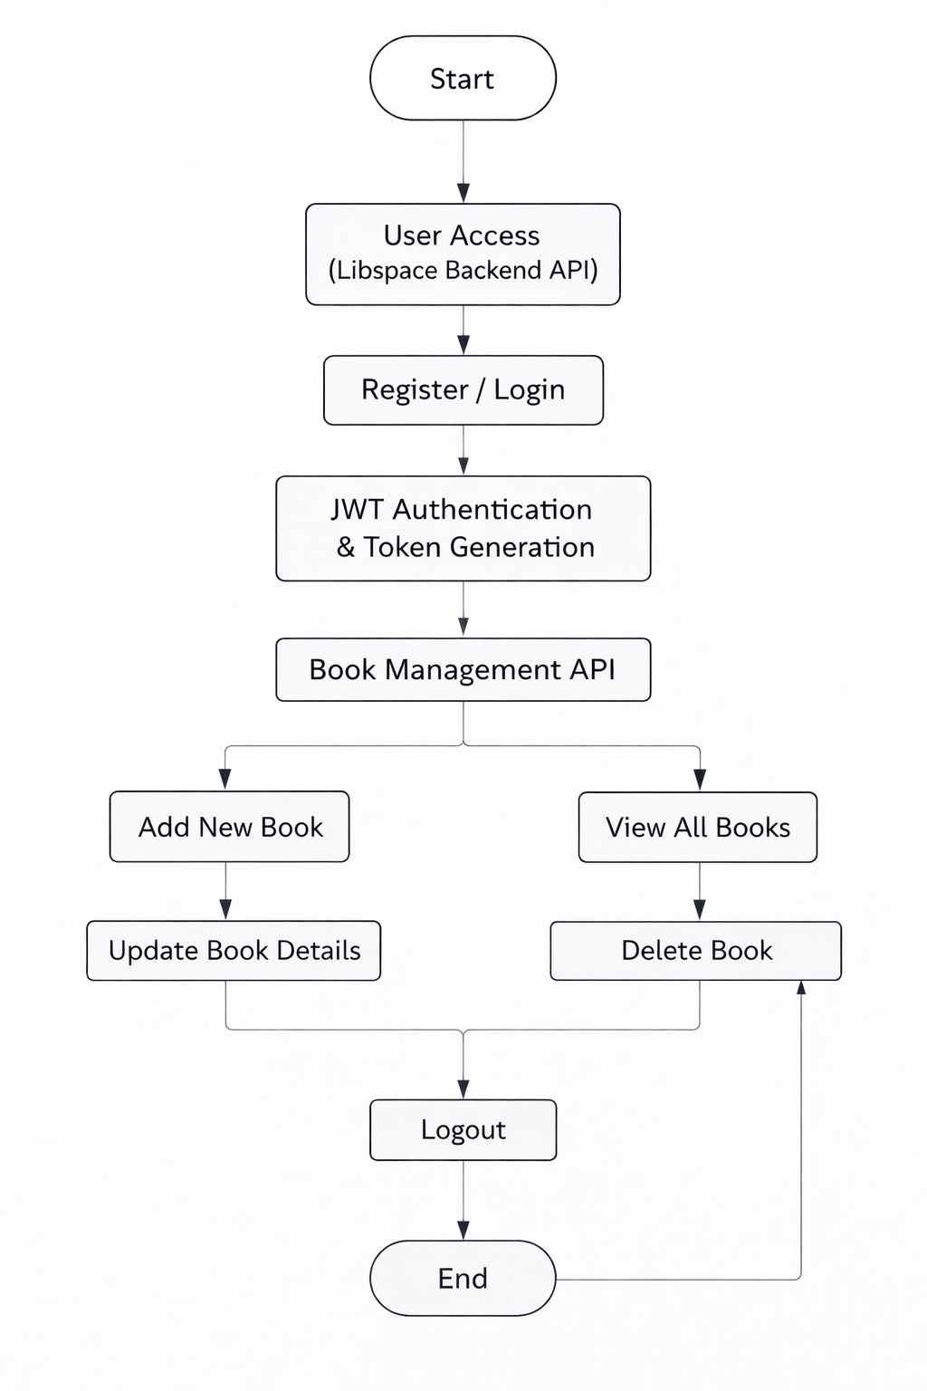
User Stories
Use the below template to list all the user stories for the product.
User Type | User Story Number | User Story / Task | Acceptance criteria | Priority | Release
Customer  (Web user) | USN-1 | As a user, I can register with email and password to create an account. | User details are stored securely in database and password is encrypted using bcrypt. | High | Sprint-1
Customer  (Web user) | USN-2 | As a user, I can login using my registered credentials. | JWT token is generated on successful login and user can access protected routes. | High | Sprint-1
Customer  (Web user) | USN-3 | As a user, I can add a new book to my account. | Book details are saved in database and linked to the logged-in user. | Low | Sprint-2

